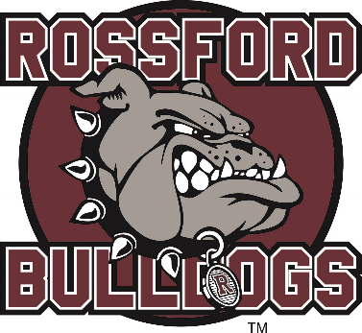**PE05729_%5b1%5dPE05730_%5b1%5d**

**Rossford Junior High**

**Cross Country**

**2022**

Thursday, August 18 Picture Day

Thursday, August 25 Lake Flyer Invitational

@ Lake Middle School

5 pm

Wednesday, August 31 Eastwood Flying Eagle Invite

@ Eastwood

4:30 pm

Tuesday, September 6 NBC Jamboree

@ Elmwood

4:45 pm

Monday, September 12 Rossford Bulldog Invitational

@ Glenwood Complex

4:30 pm

Saturday, September 17 The Battle of Turtle Creek Cross Country MS Invite @ Genoa

9:00 am

Saturday, September 24 Van Buren Invitational

@ Van Buren

9:00 am

Tuesday, September 27 NBC Jamboree

@ Otsego

4:45 pm

Saturday, October 8 Carl Fisher Booster JH CC Invitational @ Fostoria

9:00 am

Saturday, October 15 NBC Championships

@ Elmwood/Otsego (TBA)

10 am

**ROSTERS**

Rob McCartt - Coach

**Boys**

**Girls**